**Basic MySQL Interview Questions**

**1. What is MySQL?**

MySQL is a database management system for web servers. It can grow with the website as it is highly scalable. Most of the websites today are powered by MySQL.

**2. What are some of the advantages of using MySQL?**

* Flexibility: MySQL runs on all operating systems
* Power: MySQL focuses on performance
* Enterprise-Level SQL Features: MySQL had for some time been lacking in advanced features such as subqueries, [**views**](https://www.scaler.com/topics/views-in-sql/), and stored procedures.
* Full-Text Indexing and Searching
* Query Caching: This helps enhance the speed of MySQL greatly
* Replication: One MySQL server can be duplicated on another, providing numerous advantages
* Configuration and Security

**3. What do you mean by ‘databases’?**

A database is a structured collection of data stored in a computer system and organized in a way to be quickly searched. With databases, information can be rapidly retrieved.

**You can download a PDF version of Mysql Interview Questions.**

[**Download PDF**](javascript:void(0))

**4. What does SQL in MySQL stand for?**

The SQL in MySQL stands for Structured Query Language. This language is also used in other databases such as Oracle and Microsoft SQL Server.  One can use commands such as the following to send requests from a database:

SELECT title FROM publications WHERE author = ' J. K. Rowling’;

Note that SQL is not case sensitive. However, it is a good practice to write the SQL keywords in CAPS and other names and variables in a small case.

You can check out this [**SQL Tutorial**](https://www.scaler.com/topics/sql/) to learn more about SQL.

**5. What does a MySQL database contain?**

A MySQL database contains one or more tables, each of which contains records or rows. Within these rows are various columns or fields that contain the data itself.

**6. How can you interact with MySQL?**

There are three main ways you can interact with MySQL:

* using a command line
* via a web interface
* through a programming language

**7. What are MySQL Database Queries?**

A query is a specific request or a question. One can query a database for specific information and have a record returned.

**8. What are some of the common MySQL commands?**

| **Command** | **Action** |
| --- | --- |
| ALTER | To alter a database or table |
| BACKUP | To back-up a table |
| \c | To cancel Input |
| CREATE | To create a database |
| DELETE | To delete a row from a table |
| DESCRIBE | To describe a table's columns |
| DROP | To delete a database or table |
| EXIT(ctrl+c) | To exit |
| GRANT | To change user privileges |
| HELP (\h, \?) | Display help |
| INSERT | Insert data |
| LOCK | Lock table(s) |
| QUIT(\q) | Same as EXIT |
| RENAME | Rename a Table |
| SHOW | List details about an object |
| SOURCE | Execute a file |
| STATUS (\s) | Display the current status |
| TRUNCATE | Empty a table |
| UNLOCK | Unlock table(s) |
| UPDATE | Update an existing record |
| USE | Use a database |

**9. How do you create a database in MySQL?**

Use the following command to create a new database called ‘books’:

CREATE DATABASE books;

**10. How do you create a table using MySQL?**

Use the following to create a table using MySQL:

CREATE TABLE history (

author VARCHAR(128),

title VARCHAR(128),

type VARCHAR(16),

year CHAR(4)) ENGINE InnoDB;

**11. How do you Insert Data Into MySQL?**

The INSERT INTO statement is used to add new records to a MySQL table:

INSERT INTO table_name (column1, column2, column3,...)

VALUES (value1, value2, value3,...)

If we want to add values for all the columns of the table, we do not need to specify the column names in the SQL query. However, the order of the values should be in the same order as the columns in the table. The INSERT INTO syntax would be as follows:

INSERT INTO table_name

VALUES (value1, value2, value3, ...);

**12. How do you remove a column from a database?**

You can remove a column by using the DROP keyword:

ALTER TABLE classics DROP pages;

**13. How to create an Index in MySQL?**

In MySQL, there are different index types, such as a regular INDEX, a PRIMARY KEY, or a FULLTEXT index. You can achieve fast searches with the help of an index. Indexes speed up performance by either ordering the data on disk so it's quicker to find your result or, telling the SQL engine where to go to find your data.

Example: Adding indexes to the history table:

ALTER TABLE history ADD INDEX(author(10));

ALTER TABLE history ADD INDEX(title(10));

ALTER TABLE history ADD INDEX(category(5));

ALTER TABLE history ADD INDEX(year);

DESCRIBE history;

**14. How to Delete Data From a MySQL Table?**

In MySQL, the DELETE statement is used to delete records from a table:

DELETE FROM table_name

WHERE column_name = value_name

**15. How do you view a database in MySQL?**

One can view all the databases on the MySQL server host using the following command:

mysql> SHOW DATABASES;

**16. What are the Numeric Data Types in MySQL?**

MySQL has numeric data types for integer, fixed-point, floating-point, and bit values, as shown in the table below. Numeric types can be signed or unsigned, except BIT. A special attribute enables the automatic generation of sequential integer or floating-point column values, which is useful for applications that require a series of unique identification numbers.

| **Type Name** | **Meaning** |
| --- | --- |
| TINYINT | Very Small Integer |
| SMALLINT | Small Integer |
| MEDIUMINT | Medium-sized Integer |
| INT | Standard Integer |
| BIGINT | Large Integer |
| DECIMAL | Fixed-point number |
| FLOAT | Single-precision floating-point number |
| DOUBLE | Double-precision floating-point number |
| BIT | Bit-field |

**17. What are the String Data Types in MySQL?**

| **Type Name** | **Meaning** |
| --- | --- |
| CHAR | fixed-length nonbinary(character) string |
| VARCHAR | variable-length nonbinary string |
| BINARY | fixed-length binary string |
| VARBINARY | variable-length binary string |
| TINYBLOB | Very small BLOB(binary large object) |
| BLOB | Small BLOB |
| MEDIUMBLOB | Medium-sized BLOB |
| LONGBLOB | Large BLOB |
| TINYTEXT | A very small nonbinary string |
| TEXT | Small nonbinary string |
| MEDIUMTEXT | Medium-sized nonbinary string |
| LONGTEXT | Large nonbinary string |
| ENUM | An enumeration; each column value is assigned, one enumeration member |
| SET | A set; each column value is assigned zero or more set members |
| NULL | NULL in SQL is the term used to represent a missing value. A NULL value in a table is a value in a field that appears to be blank. This value is different than a zero value or a field that contains spaces. |

**18. What are the Temporal Data Types in MySQL?**

| **Type Name** | **Meaning** |
| --- | --- |
| DATE | A date value, in ' CCYY-MM-DD ' Format |
| TIME | A Time value, in ' hh : mm :ss ' format |
| DATETIME | Date and time value, in ' CCYY-MM-DD hh : mm :ss ' format |
| TIMESTAMP | A timestamp value, in ' CCYY-MM-DD hh : mm :ss ' format |
| YEAR | A year value, in CCYY or YY format |

Example: To select the records with an Order Date of "2018-11-11" from a table:

SELECT * FROM Orders WHERE OrderDate='2018-11-11'

**19. What is BLOB in MySQL?**

BLOB is an acronym that stands for a binary large object. It is used to hold a variable amount of data.  
There are four types of BLOB:

* TINYBLOB
* BLOB
* MEDIUMBLOB
* LONGBLOB

A BLOB can hold a very large amount of data. For example - documents, images, and even videos. You could store your complete novel as a file in a BLOB if needed.

**20. How to add users in MySQL?**

You can add a User by using the CREATE command and specifying the necessary credentials. For example:

CREATE USER ‘testuser’ IDENTIFIED BY ‘sample password’;

**Intermediate MySQL Interview Questions**

**21. What are MySQL “Views”?**

In MySQL, a view consists of a set of rows that is returned if a particular query is executed. This is also known as a ‘virtual table’. Views make it easy to retrieve the way of making the query available via an alias.   
The advantages of views are:

* Simplicity
* Security
* Maintainability

**22. How do you create and execute views in MySQL?**

Creating a view is accomplished with the CREATE VIEW statement. As an example:

CREATE

[OR REPLACE]

[ALGORITHM = {MERGE | TEMPTABLE | UNDEFINED }]

[DEFINER = { user | CURRENT_USER }]

[SQL SECURITY { DEFINER | INVOKER }]

VIEW view_name [(column_list)]

AS select_statement

[WITH [CASCADED | LOCAL] CHECK OPTION]

**23. What are MySQL Triggers?**

A trigger is a task that executes in response to some predefined database event, such as after a new row is added to a particular table. Specifically, this event involves inserting, modifying, or deleting table data, and the task can occur either prior to or immediately following any such event.   
Triggers have many purposes, including:

* Audit Trails
* Validation
* Referential integrity enforcement

**24. How many Triggers are possible in MySQL?**

There are six Triggers allowed to use in the MySQL database:

* Before Insert
* After Insert
* Before Update
* After Update
* Before Delete
* After Delete

**25. What is the MySQL server?**

The server, mysqld, is the hub of a MySQL installation; it performs all manipulation of databases and tables.

**26. What are the MySQL clients and utilities?**

Several MySQL programs are available to help you communicate with the server. For administrative tasks, some of the most important ones are listed here:

• **mysql**—An interactive program that enables you to send SQL statements to the server and to view the results. You can also use mysql to execute batch scripts (text files containing SQL statements).

• **mysqladmin**—An administrative program for performing tasks such as shutting down the server, checking its configuration, or monitoring its status if it appears not to be functioning properly.

• **mysqldump**—A tool for backing up your databases or copying databases to another server.

• **mysqlcheck and myisamchk**—Programs that help you perform table checking, analysis, and optimization, as well as repairs if tables become damaged. mysqlcheck works with MyISAM tables and to some extent with tables for other storage engines. myisamchk is for use only with MyISAM tables.

**27. What are the types of relationships used in MySQL?**

There are three categories of relationships in MySQL:

* **One-to-One**: Usually, when two items have a one-to-one relationship, you just include them as columns in the same table.
* **One-to-Many**: One-to-many (or many-to-one) relationships occur when one row in one table is linked to many rows in another table.
* **Many-to-Many**: In a many-to-many relationship, many rows in one table are linked to many rows in another table. To create this relationship, add a third table containing the same key column from each of the other tables

**Advanced MySQL Interview Questions**

**28. Can you explain the logical architecture of MySQL?**

The top layer contains the services most network-based client/server tools or servers need such as connection handling, authentication, security, and so forth.  
The second layer contains much of MySQL’s brains. This has the code for query parsing, analysis, optimization, caching, and all the built-in functions.

The third layer contains the storage engines that are responsible for storing and retrieving the data stored in MySQL.

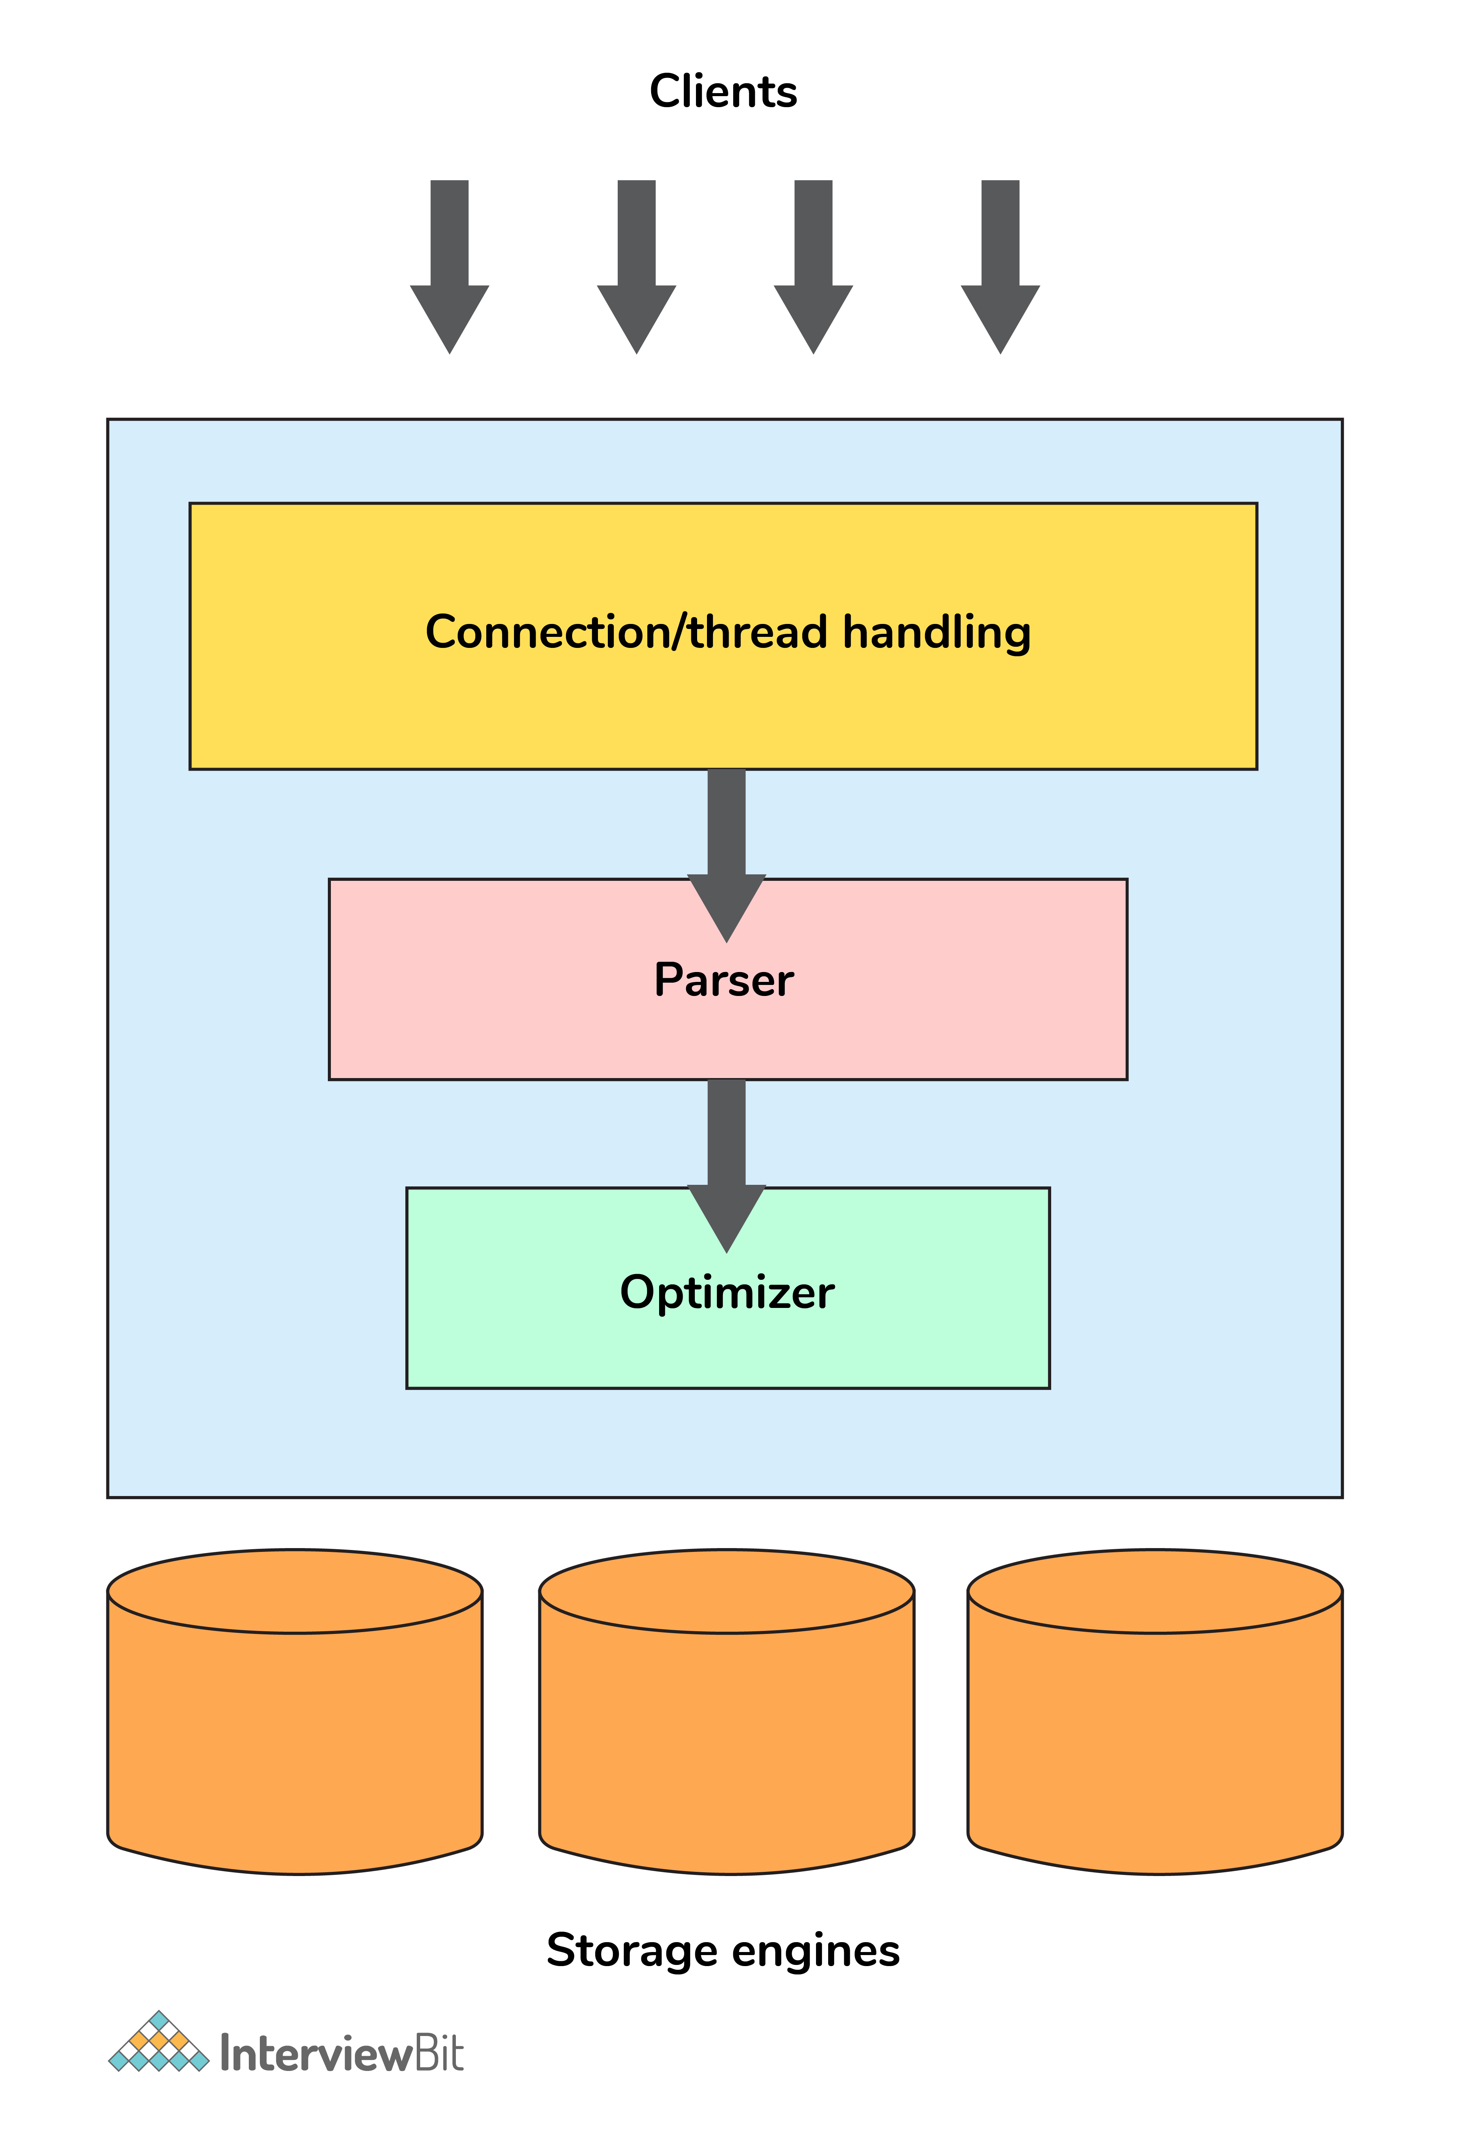

**29. What is Scaling in MySQL?**

In MySQL, scaling capacity is actually the ability to handle the load, and it’s useful to think of load from several different angles such as:

* Quantity of data
* Number of users
* User activity
* Size of related datasets

**30. What is Sharding in SQL?**

The process of breaking up large tables into smaller chunks (called shards) that are spread across multiple servers is called Sharding.   
The advantage of Sharding is that since the sharded database is generally much smaller than the original; queries, maintenance, and all other tasks are much faster.

**31. What are Transaction Storage Engines in MySQL?**

To be able to use MySQL’s transaction facility, you have to be using MySQL’s InnoDB storage engine (which is the default from version 5.5 onward). If you are not sure which version of MySQL your code will be running on, rather than assuming InnoDB is the default engine you can force its use when creating a table, as follows

**What is a Database?**

A database is a collection of all the data stored and organized electronically in a software system. It is a technology that allows us to store any type or large volume of data for easy accessibility and use.

There are so many types of databases catering to different purposes like centralized databases managing all the information for universities at a centralized location or a cloud database where the information is stored on a server that can be accessed online.

**What is RDBMS?**

In order to manage, retrieve, store and maintain the database, a system is required. That is called the Database Management System.

RDBMS(Relational Database Management System) is an advanced version of a database system that allows you to arrange, maintain, retrieve and manage databases in a tabular format. It is one of the most used tools by data analysts or database administrators for handling large amounts of data.

RDBMS is the first choice for many top-tier companies as it arranges data in tables that provide the following benefits:

* Limited Data Redundancy
* Data Security
* Easy Data recovery and backup
* Enhanced Data Usability
* Multiple Users can access data

Some of the examples of RDBMS are MYSQL, Oracle, etc.

**What is SQL?**

SQL or the Structured Query Language is a programming language that enables the function of retrieving, managing, storing the data in the relational database management system.

Just like to create an application on any system you require a programming language, likewise, it is required for managing the databases as well.

The condition of the SQL statements is declarative in nature and is known as SQL Query. There are different SQL clauses that can be used while writing the queries to define the purpose of action.  
Some of the most basic and fundamental clauses and their function are:

* **SELECT:** extracts data from the database
* **CREATE DATABASE:** creates a new database
* [**DELETE**](https://www.scaler.com/topics/delete-query-in-sql/)**:** deletes the data from the dataset
* **ALTER TABLE:** modifies a table
* **INSERT INTO:** inserts new data into a database
* **CREATE TABLE:** creates a new table within a database
* **UPDATE:** updates data in a database
* **FROM:** retrieve data from specific columns of a table
* **WHERE:** filter records based on conditions

The format and structure of every SQL query are particular and case-sensitive. One must have to be flawless in writing the SQL statements. Suppose, for extracting all data from the table data_science, the SQL query structure will be as follow:

**SELECT * FROM data_science;**

**Things to be considered**

* The statement will be started by a command.
* The end of the query will be marked by a semicolon.
* The symbol ‘*’ defines all.

Besides the common clauses, there are many SQL keywords as well like AS (query to create an alias for a table or column name), [**BETWEEN**](https://www.scaler.com/topics/sql-between-operator/) (allow to select data or values from a given range), LIMIT (retrieve data from a set number of rows in the table) to perform specific functions.

SQL is a standardized, interactive programming language that is used by many organizations due to its portability, faster query processing, and efficiency in retrieving and managing databases.

**What is MySQL?**

MySQL, now owned and managed by Oracle Corporation, is a type of relational database management system. It is an open-source platform that allows one to store, retrieve and manage relational databases.

What Is MySQL?

MySQL uses SQL queries to perform actions on the database. MySQL is one of the most popular RDBMS available that is faster, efficient, reliable, and easy to use.

Many top-tier companies like Yahoo, Google, Facebook, and many other companies have MySQL as their preferred choice of database system for managing a large volume of data.

**Benefits of using MySQL are:**

* Open-source
* Data Security
* On-demand flexibility and Scalability
* Eminent Performance
* Comprehensive Workflow Control
* Complete Transactional Assistance

It is compatible with different modern-day programming languages including C++, C, Java, Python, etc for different platforms be it Windows, Linux, or macOS. Its versatility and cross-platform adaptability make it innovative and a high-end product for its clients.

**Difference Between SQL and MySQL**

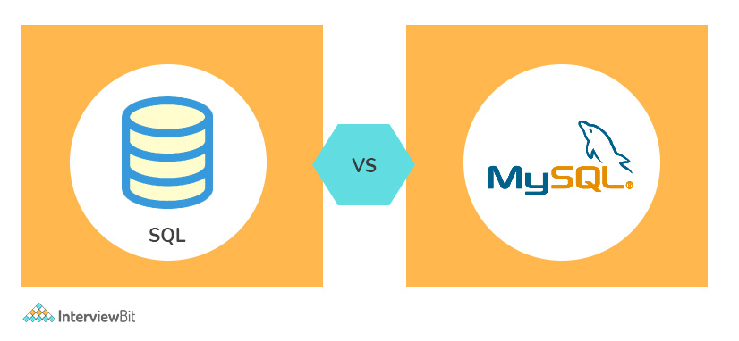Difference Between SQL and MySQL

There are times when people get confused between what is SQL and what is MySQL. So let us look at the primary difference between SQL and MySQL.

|  |  |  |
| --- | --- | --- |
| **Key Category** | **SQL** | **MySQL** |
| **Developers/Owners** | SQL is developed by Microsoft Corporation. | MySQL was developed by MySQL AB but is currently acquired and owned by Oracle Corporation. |
| **Function** | SQL is a structured query language used for managing and retrieving data from the database system. | MySQL is a Relational database system that uses SQL to query data from the databases. |
| **Syntax and Format** | The syntax and format are fixed, declarative, and easy to use. Start with the clause and end with a semicolon. | MySQL is software and not a programming language, hence it does not have any commands or particular format.  There are, however, the latest updates and versions of MySQL for enhanced performance. |
| **Licensing/Availability** | SQL is proprietary based software owned by Microsoft and not open to others for free. | MySQL is an open-source free platform that allows access to any and everyone. |
| **Platform Support** | SQL was built for WIndows, works partially for Linux, macOS with its latest versions. | MySQL is adaptable for cross-platforms, working well for Linux, macOS, and Windows. |
| **Language Support** | SQL is in itself a programming language used for database systems. | MySQL supports all the basic programming languages like C, C++, Perl, PHP, Python, Ruby, and many others. |
| **Storage Engine** | SQL supports only a single storage engine for different operations | MySQL supports different storage engines and does not take up a lot of space for different functions and operations. It also enables the plugin storage engine as well. |
| **Data Security** | SQL servers are secured as no third party or outsiders are allowed to manipulate data. | MySQL is susceptible to more security threats due to its open-source nature. It gives access to data manipulation and modification to unauthorized users as well during the run-time. |
| **Server and Database** | In SQL, the server and database work independently. This allows users or interested parties to work on databases even during recovery sessions. | MySQL servers do not work independently from databases and hence, blocks the time for the users to do anything else.  This function allows a lesser chance for data manipulation or corruption during the shifting of data into different versions of the software. |
| **Data Restoration** | Time consumed for data restoration in SQL is less for a large amount of data. | In MySQL, the process of data restoration is quite time-consuming and requires a number of SQL statements for the same. |
| **Query Execution** | SQL allows truncating a query even during execution without disabling the whole process. | MySQL does not allow you to cancel a query in the middle of execution. The user can cancel the query execution at the cost of stopping the entire process. |
| **Multilingual** | SQL is available in different languages. | MySQL is available only in a single language that is English. |
| **Connector Support** | SQL does not come up or support any connectors. | MySQL is equipped with an in-built tool known as MySQL Workbench that enables you to create, design, and build databases easily and quickly. |
| **Flexibility** | SQL supports user-defined functions and XML. | MySQL does not support any user-defined function and XML. |
| **Community Support** | The only support for SQL problems and queries is Microsoft Support care due to its highly protective usage. | MySQL has great community support as it allows free access. |
| **Advantages** | Interactive LanguageCoding not requiredPortabilityHigh SpeedMultiple Data Views | Open-source data SecurityHigh PerformanceComplete workflow Control |
| **Updates** | An SQL database follows a standard format that does not require many or any updates to be performed regularly. | It is common for MySQL to be updated frequently, as it has a number of different variants. |